**A small improvement in Event map in Rhapsody project**

In our project, we are using map to convert event name from string to OMEvent*.

+ Event name in string is data we received from other partners (IPC, Qt).

+ Event in OMEvents* is used by Rhapsody state-chart.

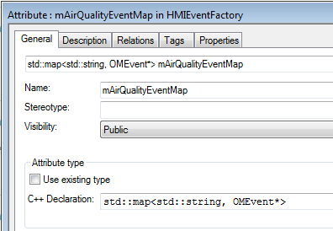

At initialization step, we have to create a list of mapping event.

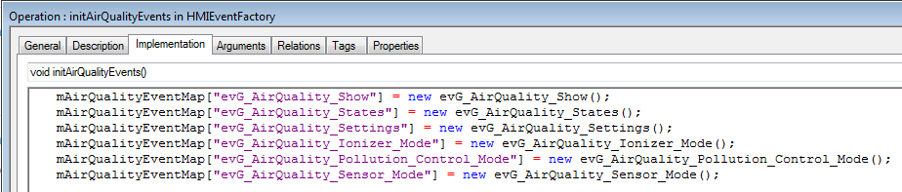

When we receive a string event, it is necessary to look for the corresponding OMEvent* in the map.

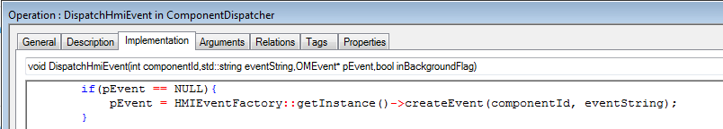

Let’s see how we are handling it and find out how memory unnecessarily used.

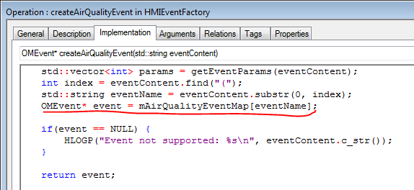

**Root cause:**

Concentrating on the command highlighted by red color. Operator [] always increases the map size by one, even if no mapped value is assigned to the eventName.

[http://www.cplusplus.com/reference/map/map/operator[]/](http://www.cplusplus.com/reference/map/map/operator%5b%5d/)

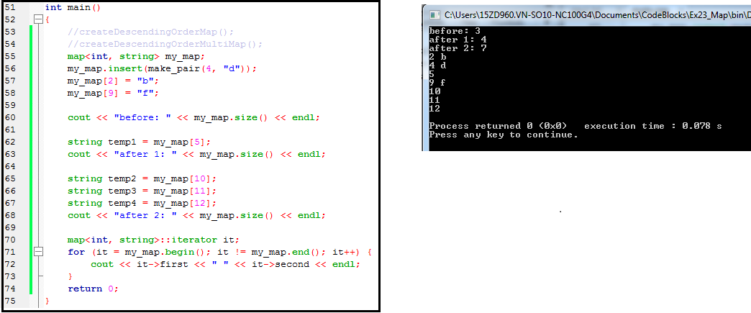

**Corrective action:**

We use function find() to search before use operator “[]”.

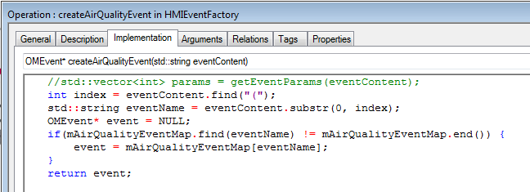

End.